Name :Sayyad Faizan
Roll no :25DCO11
Experiment No.: 7
Aim: To use Git for version control in open-source projects and implement basic repository management and collaboration workflows.

Objectives:
- To configure Git with a username and email.
- To initialize a Git repository and track a project.
- To stage and commit changes to the repository.
- To create, switch, and merge branches.
- To connect a local repository to a remote repository and push changes.

Outcomes:
- Configure Git and verify the configuration.
- Initialize a repository and check its status.
- Stage, commit, and view the commit history of changes.
- Create a branch, switch between branches, and merge them.
- Link a local repository to a remote and push the project.

Hardware / Software Required:
Linux OS / Ubuntu Terminal, Git, a GitHub or GitLab account, Text Editor

Theory:
Git is a distributed version control system that tracks changes to files over time, allowing multiple contributors to collaborate on a project without overwriting each other's work. Every change is recorded as a commit, forming a history that can be reviewed or reverted. Branching allows development to happen in isolation from the main codebase — a feature branch can be created, worked on, and later merged back into the main branch once complete. Git also supports remote repositories, hosted on platforms such as GitHub or GitLab, which act as a shared central copy of the project that collaborators can push changes to and pull changes from, enabling team-based, open-source collaboration.
Procedure:
- Configure Git with a username and email, then verify the configuration.
git config --global user.name "Your Name"
git config --global user.email "your@email.com"
git config --list
- Create a project directory and initialize a Git repository.
mkdir git-experiment
cd git-experiment
git init
- Create a README.md file with project information and check the repository status.
git status
- Stage and commit the file, then view the commit history.
git add README.md
git commit -m "Initial commit"
git log --oneline
- Create a feature branch, switch to it, and commit further changes.
git branch feature
git switch feature
git add .
git commit -m "Added feature"
- Switch back to the main branch and merge the feature branch into it.
git switch main
git merge feature
- Connect the local repository to a remote repository and push the project.
git remote add origin <repository-url>
git remote -v
git push -u origin main

Commands:
1. git config --global user.name "Your Name"
Sets the global Git username used for commits.
2. git config --global user.email "your@email.com"
Sets the global Git email used for commits.
3. git config --list
Displays the current Git configuration.
4. mkdir git-experiment
Creates a new project directory.
5. cd git-experiment
Changes into the newly created project directory.
6. git init
Initializes a new Git repository in the current directory.
7. git status
Shows the current state of the working directory and staging area.
8. git add README.md
Stages the README.md file for the next commit.
9. git add .
Stages all modified and new files in the directory.
10. git commit -m "Initial commit"
Records the staged changes as a new commit with a message.
11. git log --oneline
Displays a condensed, one-line-per-commit history.
12. git branch feature
Creates a new branch named feature.
13. git switch feature
Switches the working directory to the feature branch.
14. git checkout feature
Alternative command to switch to the feature branch.
15. git commit -m "Added feature"
Commits the staged changes made on the feature branch.
16. git switch main
Switches back to the main branch.
17. git merge feature
Merges the changes from the feature branch into the current branch.
18. git remote add origin <repository-url>
Links the local repository to a remote repository.
19. git remote -v
Verifies the configured remote repository URLs.
20. git push -u origin main
Pushes the local main branch to the remote repository and sets it as the default upstream.

Output:
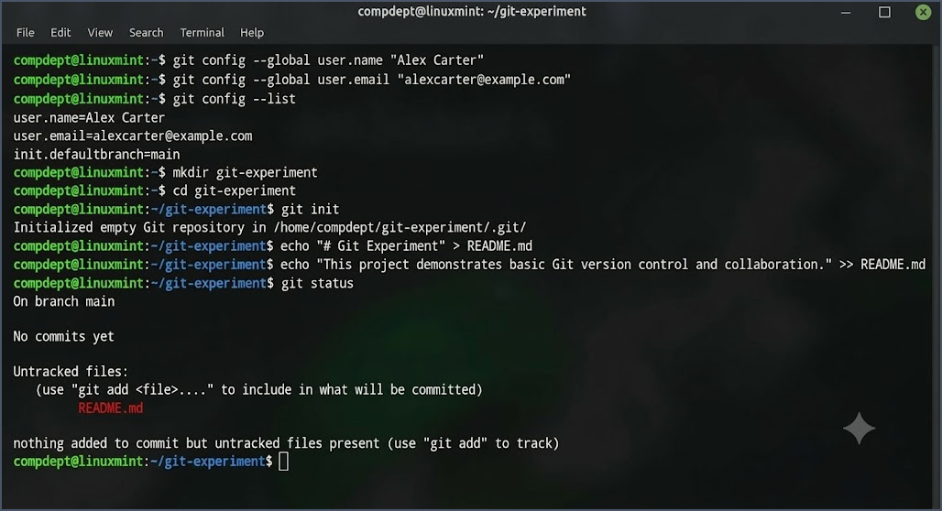

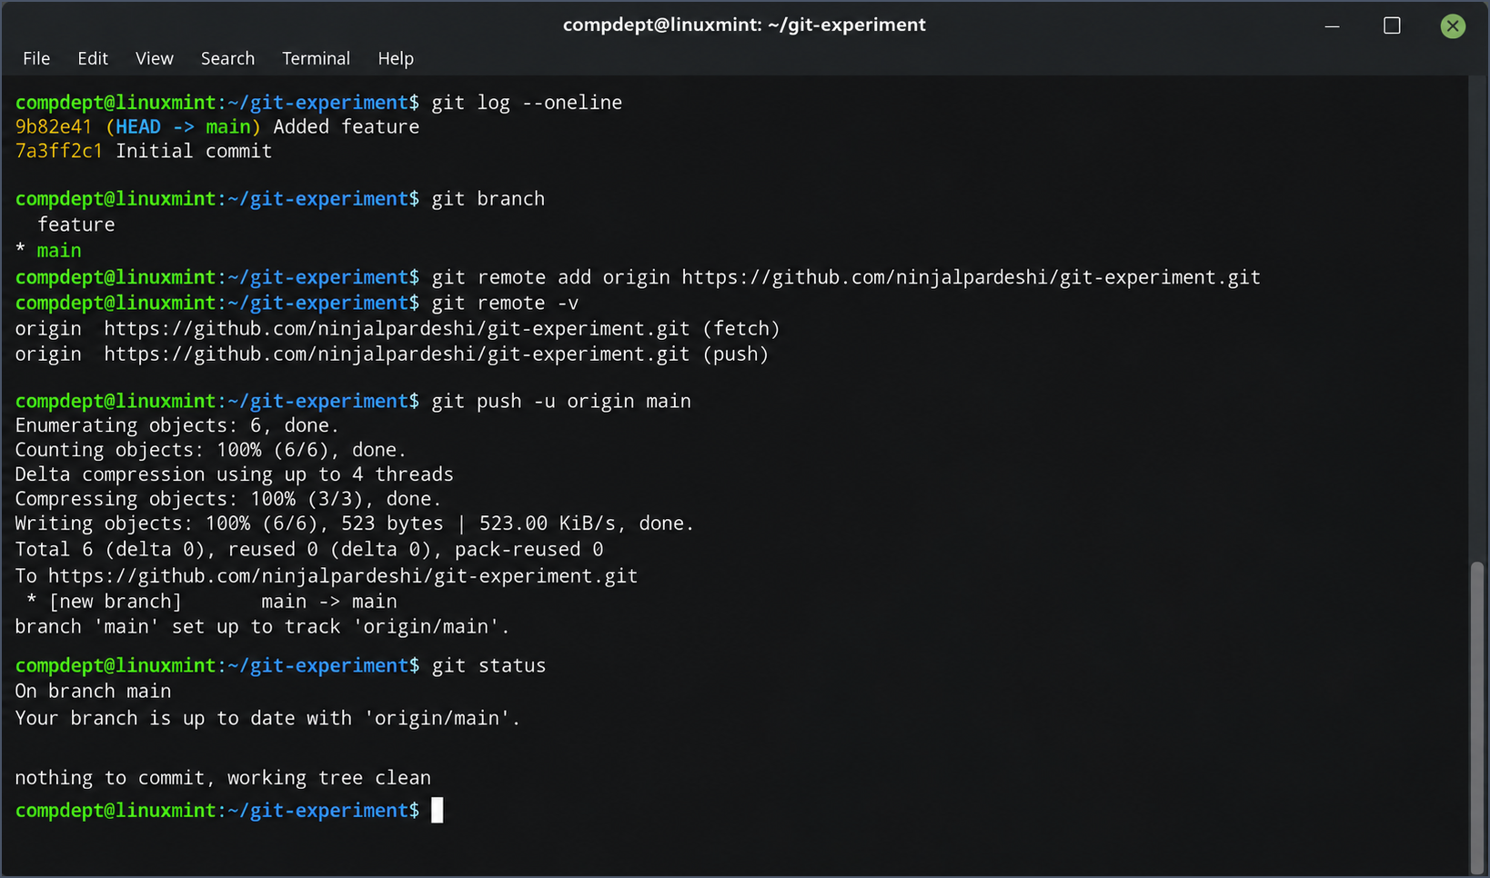
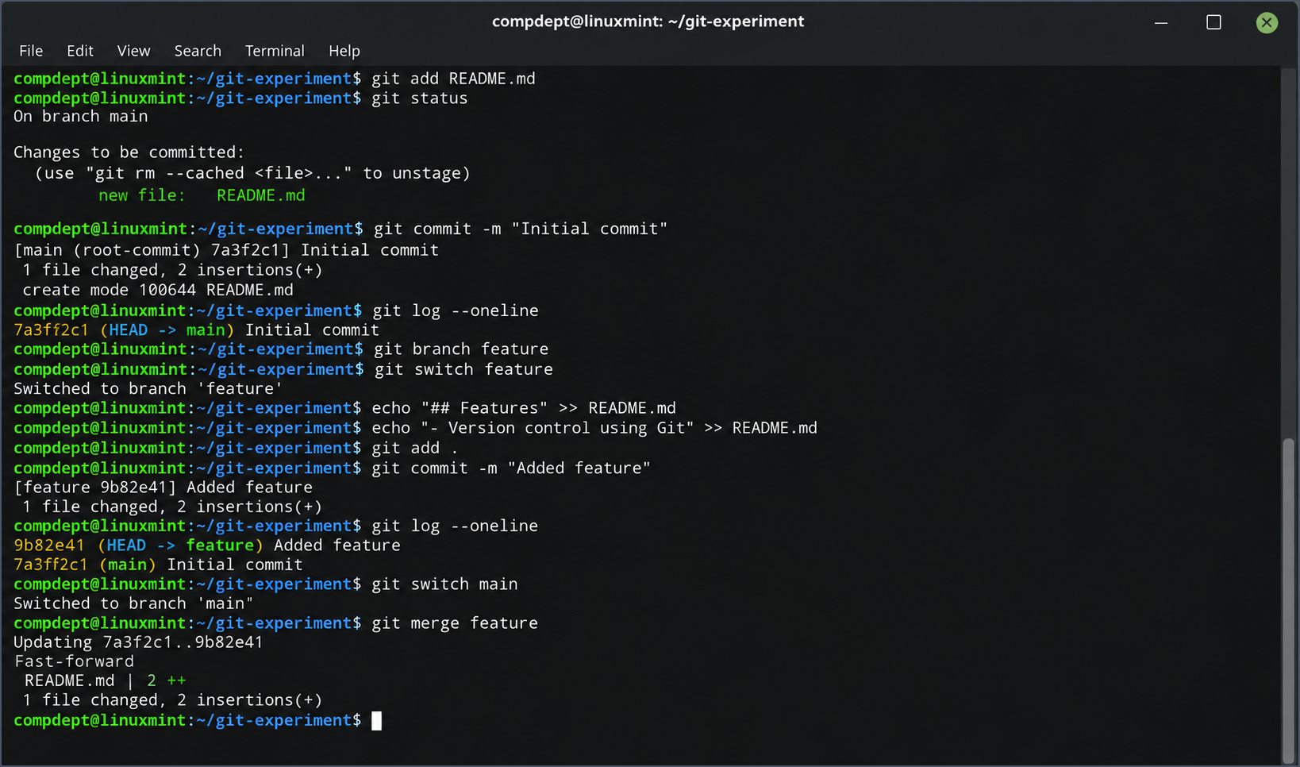
Conclusion:
This experiment demonstrated the use of Git for version control, including configuring Git, initializing a repository, staging and committing changes, creating and merging branches, and pushing a project to a remote repository. This established a basic collaborative workflow suitable for open-source development.

